NaviSER310 website report

Student reviewing: **Tyler**

Student being reviewed: **Wes**

|  |  |  |  |  |  |  |
| --- | --- | --- | --- | --- | --- | --- |
|  | **Summary of results** |  |  |  |  |  |
|  |  |  |  |  |  |  |
|  |  | Raw score | # Questions | # Answers | Score |  |
|  | Home Page | 13 | 20 | 18 | 86% |  |
|  | Task Orientation | 17 | 44 | 26 | 83% |  |
|  | Navigation & IA | 13 | 29 | 20 | 83% |  |
|  | Forms & Data Entry | 0 | 23 | 0 |  |  |
|  | Trust & Credibility | 5 | 13 | 11 | 73% |  |
|  | Writing & Content Quality | 16 | 23 | 20 | 90% |  |
|  | Page Layout & Visual Design | 20 | 38 | 33 | 80% |  |
|  | Search | 0 | 20 | 0 |  |  |
|  | Help, Feedback & Error Tolerance | 0 | 37 | 13 | 50% |  |
|  | Overall score |  | 247 | 141 | 78% |  |
|  |  |  |  |  |  |  |

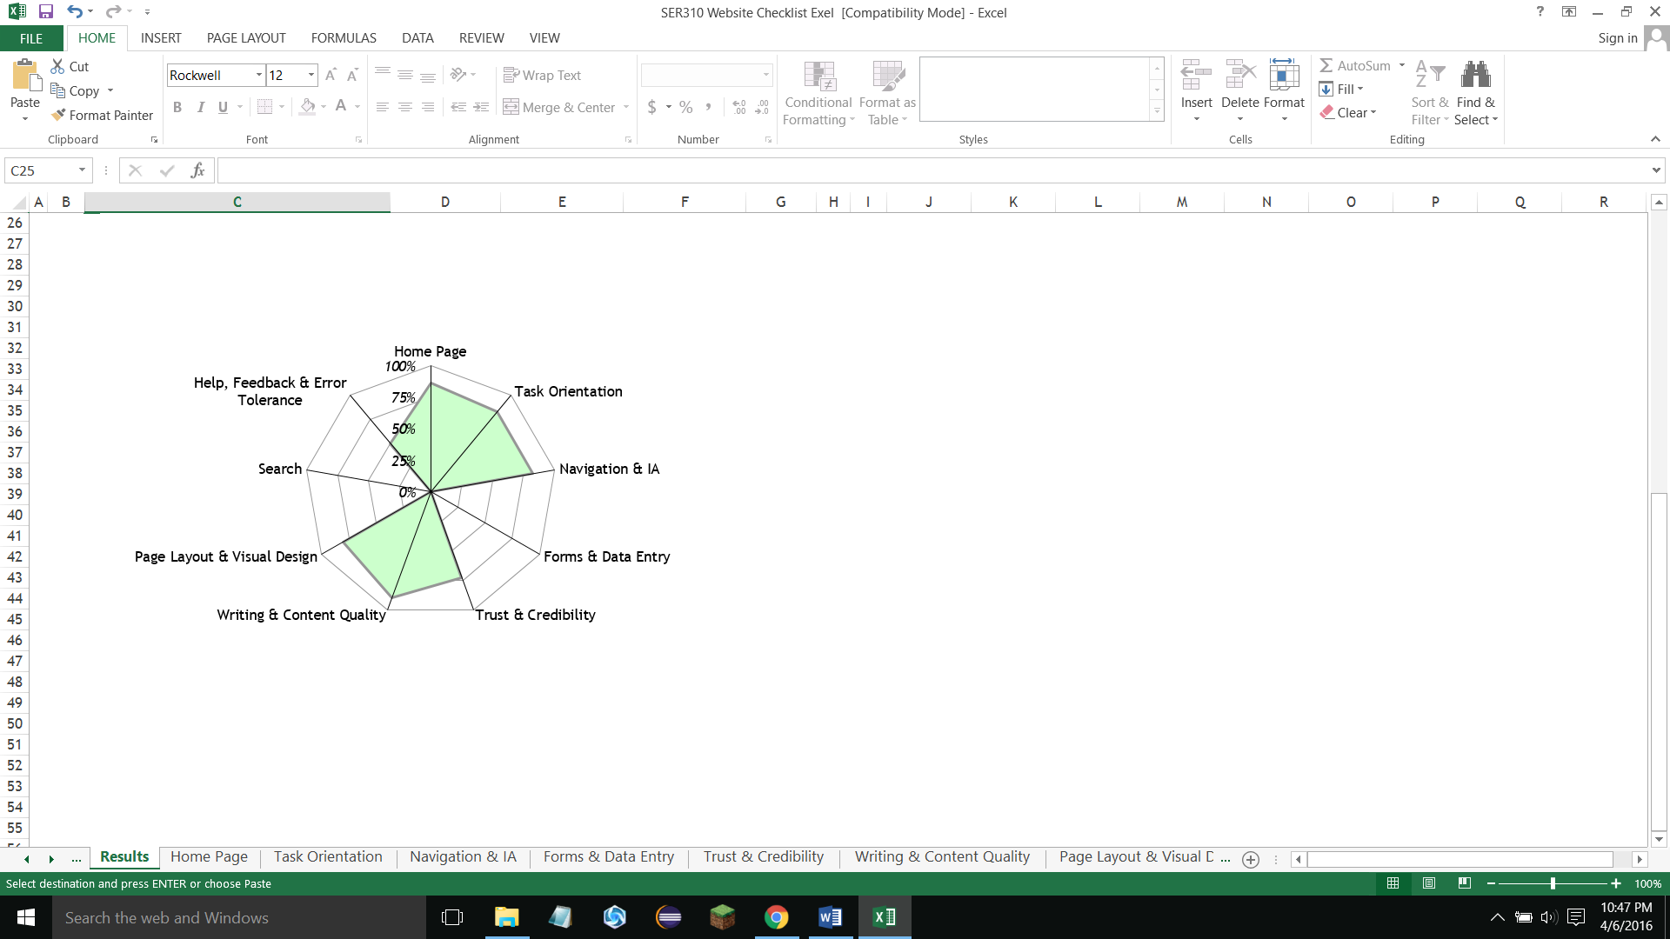

Most important findings:

The most important thing I found in this report was how much the heuristic relied on error handling for one of the sections. The “Help, Feedback, & Error Tolerance” section makes the assumption that each page had to be basically indestructible, which makes sense. But, for this assignment, we were not asked to make the site error complaint, but mere have it work without crashing. Since the site is usually only going to be navigating between pages without any complicated elements that could even cause errors in the first place, error handling seems a bit redundant.

Also, I found that the page didn’t meet any of the criteria for the searching or forms and data entry sections, mainly because that is not the intent of the site. Those sections might seem to be a 0% for the report, but I would just remove them entirely for an unbiased view.

Low score explanations:

**Task Orientation**:

* Instead of buttons linking to other pages (excluding the navigation bar), the site uses hypertext links. The solution for this would be using buttons in their places.
  + I a
* There was no way to sort information presented. The way to solve this is to have some kind of drop-down menu, or JavaScript code that sorts with a click of a button.
  + Principle: Cater to Universal Usability (not everyone wants to read through an entire graph for one piece of information)
* No error handling or help messages. Even though it’s a simple site, a single button on the bottom of each page that opens a popup with helpful information about that page could be very useful.
  + Principle: Offer Informative Feedback (self-explanatory)

**Navigation & IA**:

* There is no site map anywhere. The easiest solution is to add one on the home page, either in the form of a PDF, or as an image presented at the bottom of the page.
  + Principle: Reduce Short-Term Memory Load (hard to remember exactly where everything is on a site)
* Only one way to access each page (though the navigation bar). The best solution is add links to related pages near graphs, images, and charts.
  + Principle: Make Things Visible (such as other pages’ links while reading content)
* The home page has to be scrolled to have all of its contents seen. The solution here is to move the bulk of information on that page to other related pages.
  + Principle: Bridge Gulf of Execution and Evaluation (People expect the home page to be a navigation-oriented page, not content-based)

**Trust and Credibility**:

* There is no photo or address of the building. The best solution: add them to the home page.
  + Principle: Lower Short Term Memory Load (The user shouldn’t have to remember what the building/address from another site)

**Page Layout and Visual Design**:

* Buttons and links that have previously been access need to be able to show they have been pressed, preferably by a change in color.
  + Principle: Design Dialogues Yield Closure (users know they’ve been somewhere after returning from a link)
* Color is not used to sort through any of the information. It’s recommended that horizontal lines of color be added to the graphs of information so it’s easier to trace something from one side to the other.
  + Principle: Cater to Universal Usability (color helps users sort through information)
* The logo needs to be able to be clicked and led to either the home page, or the main site.
  + Principle: Knowledge in the World and Knowledge in the Head (users are already used to pressing a logo to return to a main page)

**Help, Feedback, and Error Tolerance**:

* The FAQ needs to be completed, and filled with questions that ordinary users would have about the site, or about the program itself.
  + Principle: Prevent Errors (harder to make errors if there is a page dedicated to prevent the user from making them)